Unity Team
Matteo Dell’Oro, Alfio Giuliano Faro, Gabriel Logronio

STORYTELLING MATERIAL

Purpose | Document holding most of the storytelling components of the game
Creation date | 22-11-2017
Current owner | Matteo Dell’Oro
Last modification | 11-12-2017

Revision History
Who | When | What
Dell’Oro | 22-11-2017 | Created this document
Dell’Oro | 23-11-2017 | Added High Concept
Dell’Oro | 24-11-2017 | Added References to Periodic Table of Storytelling
Dell’Oro | 24-11-2017 | Added Synopsis
Logronio | 25-11-2017 | Added Theme
Logronio | 11-12-2017 | Updated References to periodic Table of Storytelling

High Concept

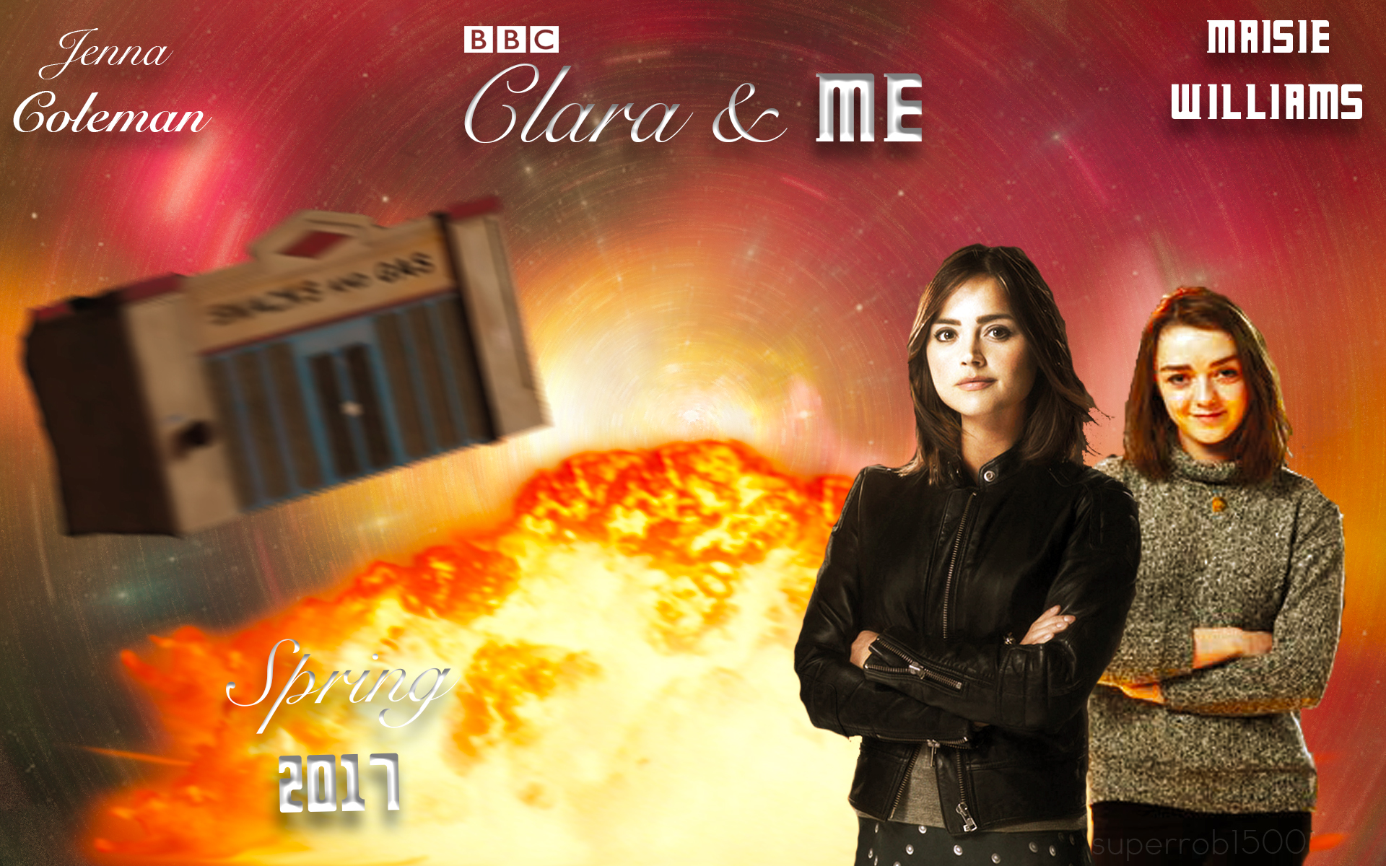 | Clara and the Doctor has parted ways. Together with Me, she takes on a journey through space and time in order to unravel a new mystery and bring order through the different timelines, while the shadow approaches.
In Doctor Who: Aftermath, take command of different characters with their diverse skill sets to make your way to distant worlds and unexplored times. Set up a party and go on a quest to investigate what’s happening in a huge factory, a murky mine or a frozen land: solve the mystery linked to unknown signal transmitters before it’s too late. | 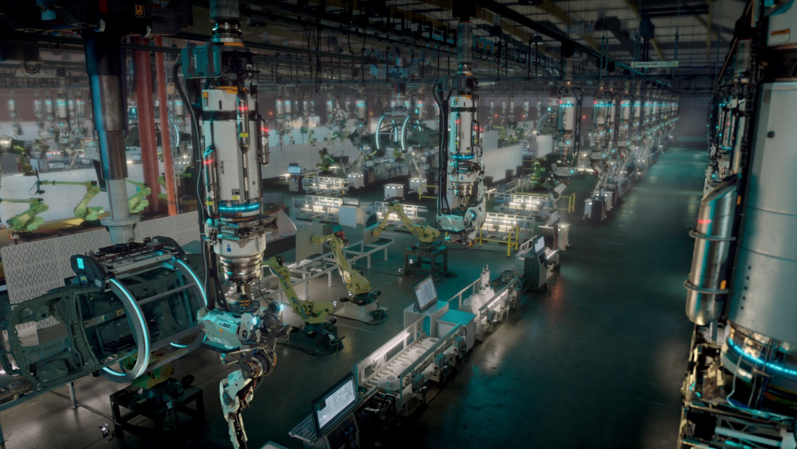
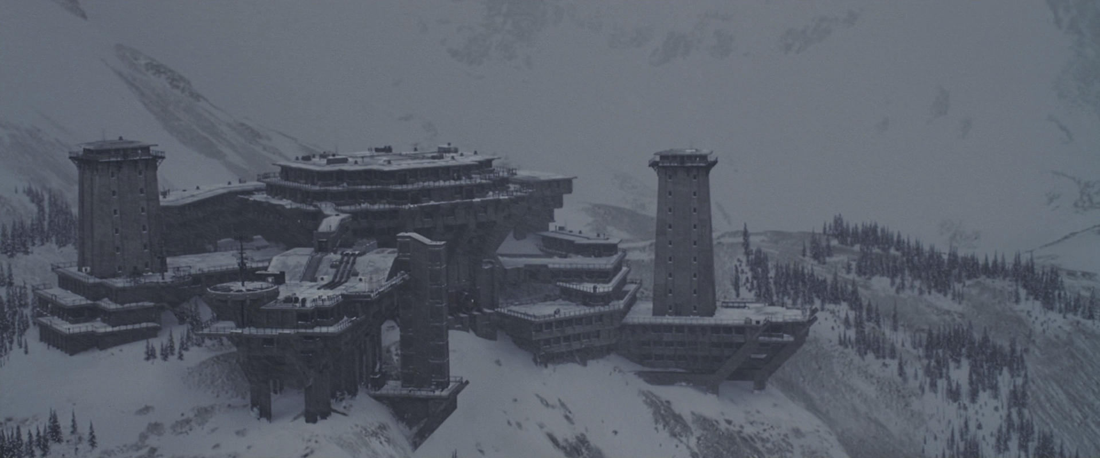 | Level up your heroes and equip them with new items and abilities to have an easier progression in the most difficult levels. Fight against scary bosses and monsters, explore every area, solve riddles and make sure to guarantee the survival of the universe.

Synopsis

We decided to outline the summary of the main choice of the player in the game. The game’s plot can be found in the “Story Document” of this very same folder.

Starting from right after the defeat of Strax, the player is going to be able to pick his party in the Tardis before diving into the missions. Clara an Me are the obligatory picks, and two characters can be chosen between: Captain Jack Harkness, Jenny the Doctor’s daughter, Alros the Silurian and Strax the Sontaran. Different picks will obviously lead to different dialogues (interchangeable one another, as the main characters – Clara and Ashildr – are going to be always in the party and can’t be opted out). Also gameplay wise having different heroes will impact the experience as shortcuts, strategies and items will only be available when a certain character is chosen before the level.

Another possible choice is made at the end of each of the four transmitter worlds: once the Doctor clones are dispatched, the player can choose whether to imprison or leave free the guardians, companions of the evil replicas. The choices will have an impact on how the story will end, as explicit in the Story Document.

Theme

As with every Doctor: Who media, the main theme is time travelling. Using the Tardis, the group is able to explore different timelines and different locations with virtually no travel time.

Another theme of the game is the hostile/friendly relationship with the different races of the Doctor: Who world, consisting in many such as Humans, Silurians, Sontarans and Zygons.

The game main objective is stopping the evil mind (Missy’s) trying to take possession of the free world and attempting to impose her control over the free will of the universe. The game events follow the struggle of the heroes in trying to stop this dangerous and apocalyptic plan and her thirst of vengeance.

References to the Periodic Table of Storytelling

Trope Name | Explanation within the story
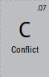 | There is an initial conflict between the team and the four Doctors that are thought to be the main enemies of the game until the reveal of the real mastermind behind the scheme, Missy. There is also a smaller conflict within the group, between Clara’s idealism and Me’s cynicism and their way of approaching the problems.
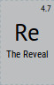 | After defeating the four evil Doctors, the team receive a message from Missy herself, revealing her plans and explaining her reasons.
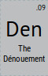 | At first the team looks for clues trying to understand why has the Doctor become evil and to understand his plans following the trail of signals. When they defeat them Missy reveal them the real plan and how she was in the background the whole time.
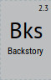 | The context of the Doctor Who Season 9 finale, “Hell Bent” is essential to understand the starting point of the game’s story. The backstory of the other characters is less important, but might help to understand their personalities.
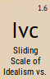 | Inside the team there’s a conflict between Clara’s idealistic view of the world and her Me’s, that is the opposite being cynic and utilitarian. This reflects in their way of approaching problems and the way they want to solve them: is up to the player to decide which side to support.
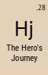 | The whole game is a journey of a team of heroes through different worlds and different times in order to discover an evil plan.
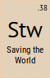 | The efforts of the group in order to prevent Missy’s plan to conquer the universe, so they can preserve the peace and freedom.
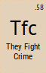 | Clara and Me might have different view of the world, but they team up united by their will to defeat the evil, even if they have their own ways.
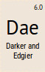 | The story starts light but takes a dramatic turn after the death of Alros’ little brother. Since that moment the team gets serious realizing the huge threat that looms upon the whole universe. The story than gets darker and edgier.
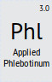 | Zeiton-7 is the material fuelling the plot, searched by Missy throughout the whole universe, even without apparent a scientific explanation of its effects.
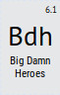 | Jack and his team, Jenny and Sam, comes to the rescue of Clara and Me when they encounter the zygons, saving their lives with style.
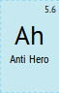 | Me has an anti heroic way of approaching the problems, representing the “darker” side of the group, and she will try to persuade the player to follow her view, i.e. to lock up the guardians the assist the evil Doctors in the four planets.
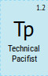 | Clara is a technical pacifist as she always tries to find a way to solve problems without using violence, and if she does she makes sure nobody gets killed doing so.
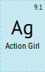 | Clara, Me and Jenny are all characters that are ready to get into action without fear, bad-asses and action-based female figures.
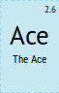 | Jack, a master in the art of fighting with various weapons and guns, and highly respected among the group for his skills and abilities.
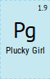 | Clara, a decisive female figure who never gives up no matter how hard the situation seems impossible to solve, a way can always be found, i.e. when they are captured and get imprisoned she doesn’t lose her hope and finds a way to escape and free her team.
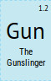 | Jack and Jenny, are both very good at using a large set of different weapons and guns that can help in many battles making them really ductile.
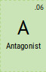 | Missy, the one main figure whose interests goes against the heroes party. She’s the one big enemy which controls, directly or undirectly, all the other villains in the game.
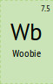 | Alros, in the moment when he loses his younger brother, becomes a character which causes a sense of pity in the player, seen his extreme pain reaction.
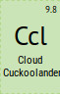 | Sam, a weird character with his own world and his own rules. He’s a sort of outcast in the group, which is one of the reasons why he doesn’t join the party in the action but remains as a mentor figure in the Tardis.
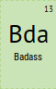 | Clara, Ashildr, Jack and Jenny, all characters with strong personalities and traits of skill, bravery and attitude. In several instances of the story they show this trait by taking control of the situation.
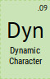 | Alros, evolving through the story with different layers: he’s altruistic when he finds the team in Roswell, he’s sad when he has just lost his younger sibling, he’s angry when he looks for revenge against Missy.
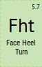 | Thought to be: the Doctors found on the various worlds, which eventually turns out to be clones. As the Doctors were the main protagonists of the original series, an eventual switch to the dark side would be seen as a betrayal from the game heroes.
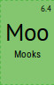 | Various enemies throughout the story, who just get defeated without too much difficulty by the heroes.
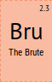 | War, the 9th Doctor clone, is a character always trying to pick up a fight, whether it is with an enemy or even one of his subject, just to show his brutal strength and it makes it impossible to reason with him.
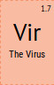 | Famine, the 10th Doctor clone, is a genius scientist, unfortunately his mind is always aiming towards finding new ways to torture and maim people, to the point that he invented a poison that corrode any organic substance slowly but painfully that he uses in battles and just to have some fun.
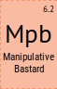 | Conquest, the 11th Doctor clone, is extremely gifted in his oratory ability, but he uses his skill to manipulate and convince people to do everything he needs to be done, whether they want it or not.
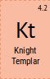 | Death, the 12th Doctor clone, really thinks to be in the right side, supports Missy with all his strength and seeks revenge as a rightful punishment to whoever tries to stop him and his Mistress. The end justifies the means.
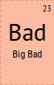 | Missy, is the Mistress of the evil doctors, she is the one pulling the strings in the background and she is the final antagonist of the whole story.
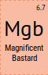 | Missy: she is bold and audacious but extremely calculative too. Through the symbol that the Doctors represent, tricks everyone with her mastery in manipulation and her brilliance. Even when the team manages to defeat her subject Doctors, she doesn’t lose her cool and quickly comes out with a new plan. With her extravagance and her charisma every situation is good to put herself on a show.
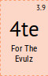 | Missy is moved both by her deep motivations and extreme keen to evil. She always tends to act badly even for unknown reasons, and when she doubts on how to behave, she finds an extremely easy answer in acting evil “just because she can: why not?”.
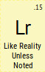 | Elements, every object and place in the story are exactly the same as their counterparts in the real world, unless expressly stated, in this case i.e. a screwdriver can be sonic and be much more useful than a real one.
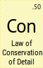 | The only details noted in the story are the ones important to the story itself, with everything that is not essential is left out not to create too burdensome environment.

